**SUPPLEMENTARY INFORMATION**

**CD4+c-Met+Itgα4+ T cell subset promotes murine neuroinflammation**

Mahdia Benkhoucha1, Ngoc Lan Tran1, Gautier Breville1,2, Isis Senoner1, Paul F. Bradfield3, Thalia Papayannopoulou4, Doron Merkler5, [Thomas Korn](https://pubmed.ncbi.nlm.nih.gov/?term=Korn+T&cauthor_id=24681001)6,7,8 and Patrice H. Lalive1,2*

1Department of Pathology and Immunology, Faculty of Medicine, University of Geneva, Geneva, Switzerland.

2Department of Neurosciences,Division of Neurology, University Hospital of Geneva, Geneva, Switzerland.

3MesenFlow Technologies SARL, Chemin des Aulx 14, Geneva, Switzerland.

4Division of Hematology, Department of Medicine, University of Washington, Seattle, WA

5Division of Clinical Pathology, Department of Pathology and Immunology, Faculty of Medicine, University of Geneva, Geneva, Switzerland.

6Department of Neurology, Klinikum rechts der Isar, Technical University of Munich, Munich, Germany.

7Institute for Experimental Neuroimmunology, Klinikum rechts der Isar, Technical University of Munich, Munich, Germany.

8Munich Cluster for Systems Neurology, SyNergy, Munich, Germany.

**\*Corresponding author:** Prof. Patrice H. Lalive, Phone: +41 22 372 83 18, Fax: +41 22 372 83 32, Email: patrice.lalive@hcuge.ch

**SUPPLEMENTARY FIGURES**

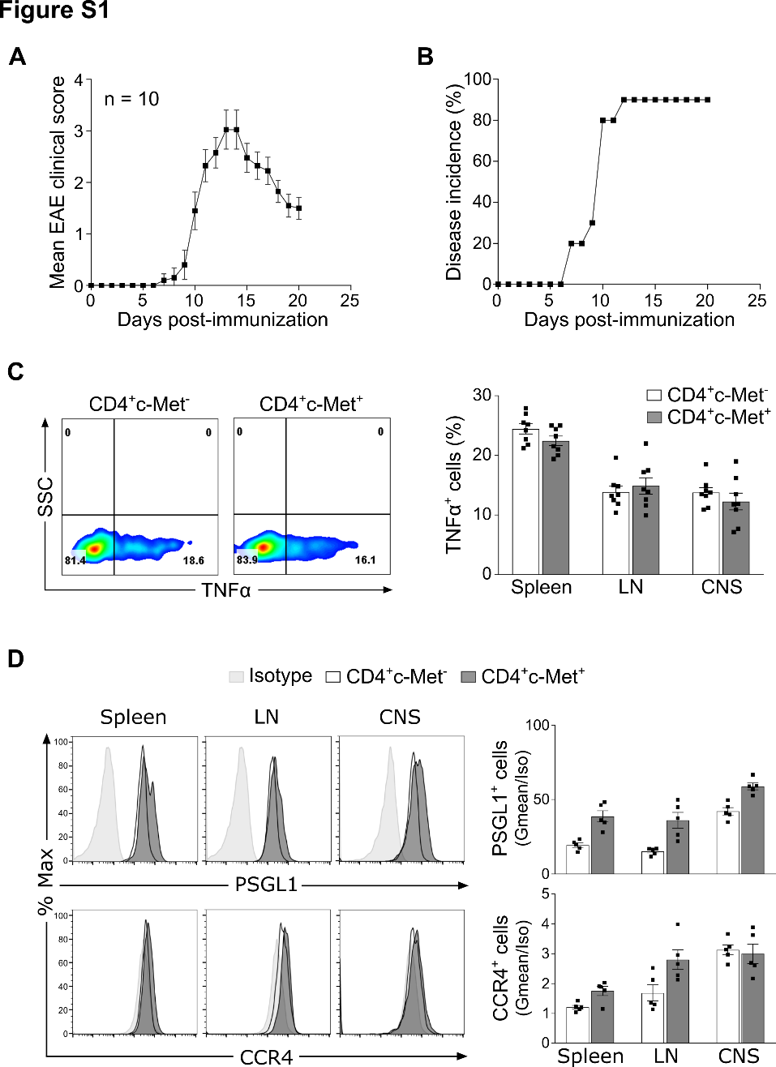

**Figure S1. MOG35-55-induced EAE clinical score**

**(A)** MOG35–55-induced EAE in C57BL/6J mice by immunization with 200μg of MOG35–55, emulsified in CFA on day 0. Mice also received 300ng of PTX i.v. on days 0 and 2. EAE disease severity was followed until chronic phase (d21) and mean clinical score ± SEM for n=10 mice/group were shown. **(B)** Percentage of disease incidence of immunized mice described in (A) is shown. **(C)** TNFα production by CD4+ T lymphocytes isolated at peak disease (d14) from spleen, LN and CNS after in vitro stimulation. Representative flow cytometric plots (left panels) and quantification (right panels) of CD4+c-Met- vs c-Met+ T cells are depicted. Mean values ± SEM for n=8 mice/group are shown. **(D)** Representative flow cytometric histograms (left panels) and Gmean/isotype quantification (right panels) of CCR4 and PSGL1 expression on CD4+c-Met- and c-Met+ T cells from spleen, LN and CNS extracted at peak disease (d14). Mean values ± SEM for n=5 mice/group are shown.

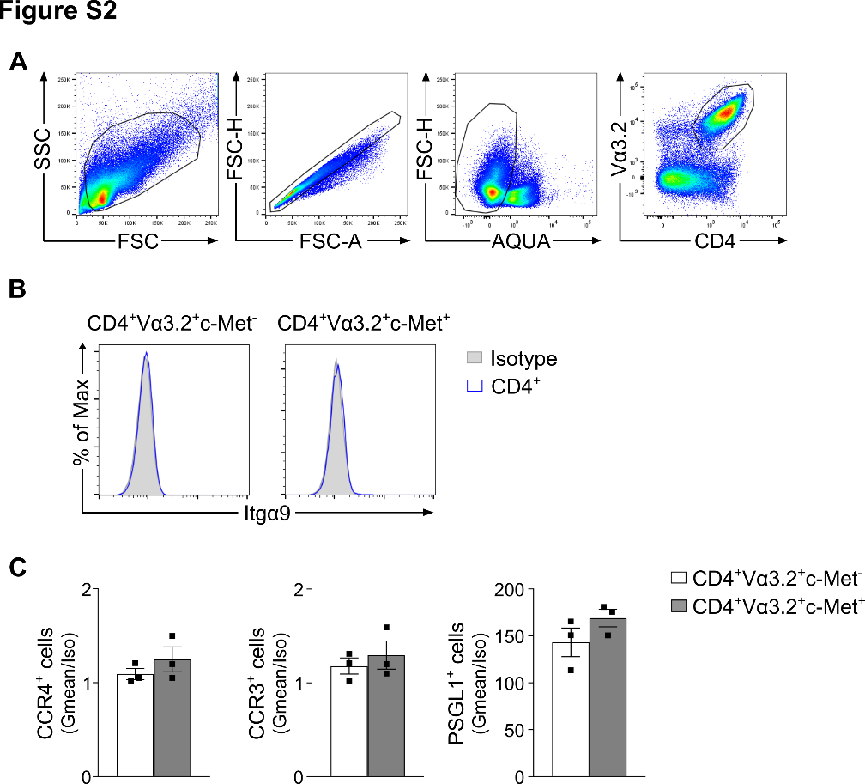

**Figure S2. 2D2 CD4+Vα3.2+c-Met- and c-Met+ polarized Th1 cells characterization *in vitro***

**(A)** Flow cytometry gating strategy for the identification of 2D2 CD4+Vα3.2+ T cells. Live lymphocytes were first selected for their morphology using FSC/SSC parameters, followed by the exclusion of doublets and dead cells (AQUA), and CD4+Vα3.2+ T lymphocytes were subsequently selected. **(B)** Representative flow cytometric histograms at day 6 post-Th1 differentiation of the expression of Itgα9 on 2D2 CD4+Vα3.2+c‐Met- and c‐Met+ T cells. **(C)** Gmean/isotype quantification by flow cytometry of 2D2 polarized Th1 cells at day 6 post-differentiation of CCR4, CCR3 and PSGL1 gated on 2D2 CD4+Vα3.2+c‐Met- and c‐Met+ T cells. Data are representative of three independent experiments and mean values ± SEM for n=3 mice/group are shown.

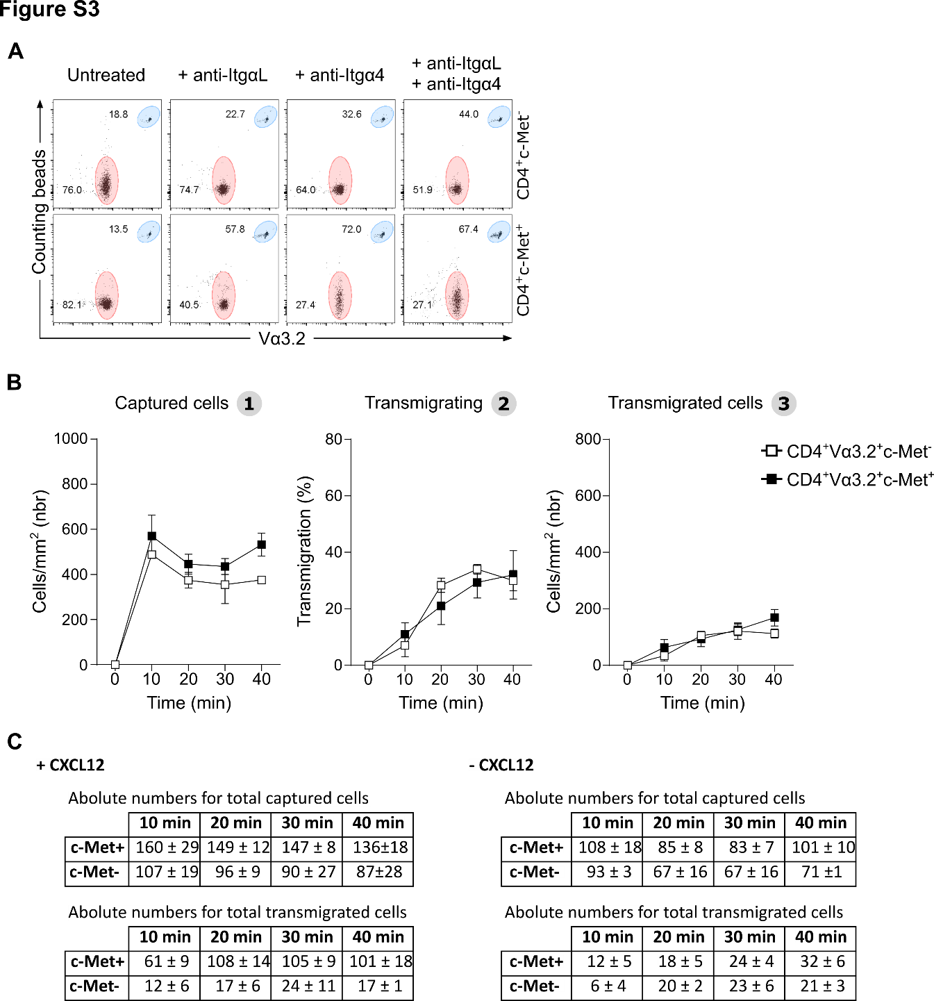

**Figure S3. Trafficking profiles of 2D2 c-Met+ polarized Th1 T cells on non-activated HUVECs in an *in vitro* flow assay system**

**(A)** Representative flow cytometry plots for the normalization of the relative number of transmigrated cells (red population) using fluorescent counting beads (blue population) upon stimulation with indicated antibodies. **(B)** Adherent polarized 2D2 CD4+Vα3.2+c-Met- and c-Met+ Th1 T cells in coculture on non-activated HUVECs were individually tracked and monitored for transmigration between different compartments for 45 minutes. Captured (left panel), transmigrating (center panel) and transmigrated (right panel) T cells were analyzed separately. Data are presented as the means of 3 fields and are representative of three independents experiment. Mean values ± SD are shown. **(C)** Absolute numbers for c-Met- and c-Met+ captured (top panels) and transmigrated (bottom panels) cells in presence (left panels) or absence (right panels) of CXCL12 at indicated time points counted during the *in vitro* flow assay system described in Fig. 4C and D.

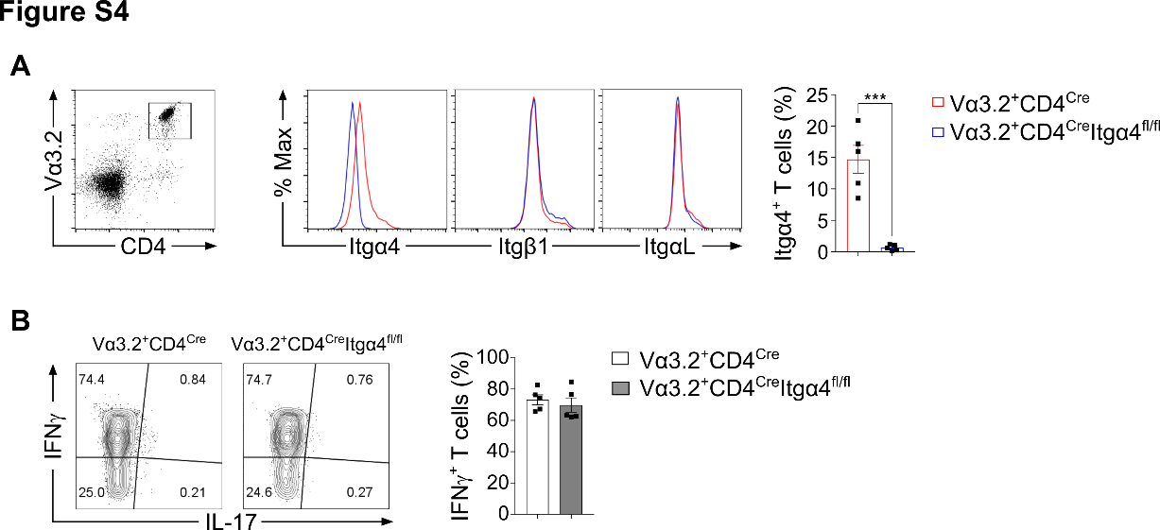

**Figure S4. Integrin and cytokine expression of Th1 cells from 2D2 Vα3.2+CD4CreItgα4fl/fl and Vα3.2+CD4Cre control littermate mice**

**(A)** Spleen cells from control 2D2 Vα3.2+CD4Cre and2D2 Vα3.2+CD4CreItgα4fl/fl mice were polarized *in vitro* into Th1 cells and the expression of Itgα4, Itgβ1 (VLA4 second associated subunit) and ItgαL (LFA-1 integrin subunit) were assessed by flow cytometry. Data are representative of three independent experiments and mean values ± SEM for n=5 mice/group are shown; ***p≤0.001 by unpaired two‐tailed Student's t‐test. **(B)** Th1 polarized cells were stimulated with PMA/ionomycin and analyzed for cytokine secretion by intracellular cytokines staining. Percentages of IFNγ and IL-17 expressing Th1 cells from control 2D2 Vα3.2+CD4Cre and 2D2 Vα3.2+CD4CreItgα4fl/fl mice were determined. Data are representative of three independent experiments and mean values ± SEM for n=5 mice/group are shown.

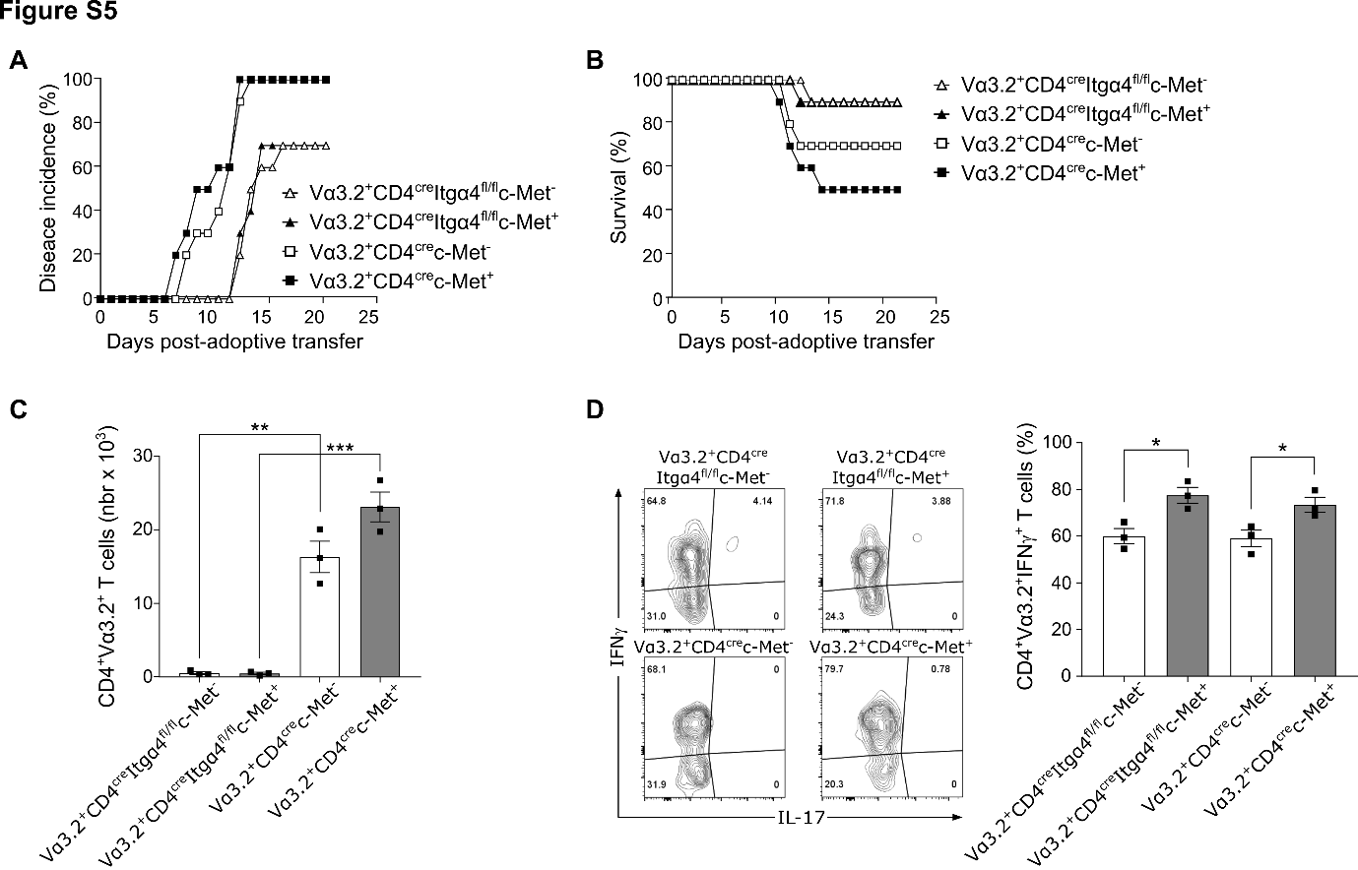

**Figure S5. Adoptive transfer of Itgα4-deficient 2D2 CD4+c-Met+ Th1 cells induces delayed and reduced EAE incidence, severity, and decreased infiltrated T cell quantifications**

**(A)** Percentage of disease incidence of EAE induced mice described in **Fig. 5** are shown. **(B)** Survival curves of EAE induced mice described in **Fig. 5** are shown. **(C)** Quantification of CNS CD4+Vα3.2+ infiltrating T cells by flow cytometry at day 18 post-Th1 transfer. Data are representative of 2 independent experiments and mean values ± SEM for n=3 mice/group are shown; **p≤0.01, ***p≤0.001 by two-way ANOVA followed by Tukey’s post hoc test. **(D)** Representative flow cytometric plots of IFNγ and IL-17 production by Th1 infiltrating cells in the CNS at day 18 post-CD4+Vα3.2+ Th1 cells transfer and quantification of IFNγ-producing CD4+Vα3.2+ Th1 cells is shown on the right. Data are representative of 2 independent experiments and mean values ± SEM were shown for n=3 mice/group; *p≤0.05 by unpaired two‐tailed Student's t‐test.

**SUPPLEMENTARY TABLE**

**Table S1: Antibodies for flow cytometry**

|  |  |  |  |  |  |
| --- | --- | --- | --- | --- | --- |
| **Antibodies** | **Species reactivity** | **Clone** | **Fluorochrome** | **Supplier** | **RRID number** |
| **CD45** | **Anti-mouse** | **30-F11** | **APC-Cy7** | **BD Pharmingen** | **AB_394606** |
| **CD4** | **Anti-mouse** | **RM4-5** | **PercP-Cy5.5** | **eBioscience** | **AB_467067** |
| **Vα3.2** | **Anti-mouse** | **RR3-16** | **APC, PercP-ef710** | **eBioscience** | **AB_10854272** |
| **CD3** | **Anti-mouse** | **17A2** | **BV605** | **BD Horizon** | **AB_2732063** |
| **c-Met** | **Anti-mouse** | **eBioclone7** | **FITC** | **Invitrogen** | **AB_494112** |
| **CD44** | **Anti-mouse** | **IM7** | **BV605, BUV737** | **BD Horizon** | **AB_2870126** |
| **CD69** | **Anti-mouse** | **H1.2F3** | **BUV 395** | **BD Bioscience** | **AB_2739968** |
| **ItgαL** | **Anti-mouse** | **M17/4** | **APC** | **Invitrogen** | **AB_11217471** |
| **Itgα4** | **Anti-mouse** | **R1-2** | **Pe-Cy7** | **Invitrogen** | **AB_2744779** |
| **Itgα9** | **Anti-mouse** | **Polyclonal** | **PE** | **Invitrogen** | **AB_2610554** |
| **Itgβ1** | **Anti-mouse** | **HMβ1-1** | **PE** | **Biolegend** | **AB_312884** |
| **PSGL1** | **Anti-mouse** | **2PH1** | **BV421** | **BD Horizon** | **AB_2737808** |
| **CXCR3** | **Anti-mouse** | **CXCR3-173** | **PE-ef610** | **Invitrogen** | **AB_2802385** |
| **CCR2** | **Anti-mouse** | **SA203G11** | **BV650** | **Biolegend** | **AB_2721553** |
| **CCR4** | **Anti-mouse** | **2G12** | **PE** | **Biolegend** | **AB_1236367** |
| **CCR5** | **Anti-mouse** | **HM-CCR5** | **APC, PE-Cy7** | **Biolegend** | **AB_2617013** |
| **CCR6** | **Anti-mouse** | **29-2L17** | **BV421** | **Biolegend** | **AB_2715923** |
| **CCR8** | **Anti-mouse** | **SA214G2** | **PE** | **Biolegend** | **AB_2617032** |
| **CCR3** | **Anti-mouse** | [**J073E5**](https://www.biolegend.com/en-us/search-results?Clone=J073E5) | **PE-Cy7** | **Biolegend** | [**AB_2565739**](http://antibodyregistry.org/AB_2565739) |
| **INFγ** | **Anti-mouse** | **XMG1.2** | **APC** | **Invitrogen** | **AB_2688063** |
| **TNFα** | **Anti-mouse** | **MP6-XT22** | **PE** | **BD Pharmingen** | **AB_395380** |
| **IL-17** | **Anti-mouse** | **eBio17B7** | **PercP-Cy5.5** | **eBioscience** | **AB_10732356** |
| **GM-CSF** | **Anti-mouse** | **MP1-22E9** | **BV421** | **BD Bioscience** | **AB_2738929** |
| **CD3** | **Anti-human** | **UCHT1** | **APC-Cy7** | **Biolegend** | **AB_893299** |
| **CD4** | **Anti-human** | **OKT4** | **PE-Cy7** | **Biolegend** | **AB_571959** |
| **CD49d/Itgα4** | **Anti-human** | **9F10** | **BV711** | **Biolegend** | **AB_2687198** |

**SUPPLEMENTARY VIDEO**

**Video S1. Bio-imaging analysis of shear flow assay**

Time-lapse recording of CD4+Vα3.2+c-Met- (left movie) and CD4+Vα3.2+c-Met+ (right movie) Th1 cells on activated HUVECs under flow for 50 min. Captured Th1 cells that subsequently transmigrate under the HUVEC monolayer switch from a phase-white to a phase-black appearance.